**VR HORROR GAME**

|  |  |  |
| --- | --- | --- |
| Prof. Punam Bagul  Guide  KCCEMSR, Thane East  [punam.bagul@kccemsr.edu.in](mailto:punam.bagul@kccemsr.edu.in) | Ritvik Babre  Student  KCCEMSR, Thane East  [ritvikbabre@kccemsr.edu.in](mailto:ritvikbabre@kccemsr.edu.in) | Hitesh Behera  Student  KCCEMSR, Thane East  [hiteshbehera@kccemsr.edu.in](mailto:hiteshbehera@kccemsr.edu.in) |
| Shruti Sabbani  Student  KCCEMSR, Thane East  [shrutisabbani@kccemsr.edu.in](mailto:shrutisabbani@kccemsr.edu.in) | Swapnil Yadav  Student  KCCEMSR, Thane East  [swapnilyadav@kccemsr.edu.in](mailto:swapnilyadav@kccemsr.edu.in) |  |

**ABSTRACT**

The horror game serves as a medium to introduce VR and integrate as a technology into everyday life as a lifestyle choice. Through immersive environments, we aim to showcase the transformative potential of interactive computing.

**OBJECTIVE**

The VR horror game leverages immersive environments to evoke strong emotional responses, tapping into the rising interest in gaming and timeless appeal of ghost stories. By integrating cutting-edge VR technology, we aim to create a unique experience that merges traditional cultural horror stories with the future of gaming.

**FEATURES**

**GAME MANAGER:**

The GameManager serves as the central controller for managing game states, user interface, input, events, scene transitions, game logic and win-lose condition. It syncs the elements to ensure a cohesive player experience.

**HEAD TRACKING**:

Head tracking in VR horror games on Android involves using the device's built-in sensors such as gyroscope to track head movements. Unity's Android VR integration enables developers to update the virtual camera's position and orientation based on this tracking data, ensuring alignment with real-world movements.

**ITEM SPAWNER:**

An algorithm to spawn items randomly over the map. The items spawn randomly given points out of many strategically placed points. For this randomness it improves the replay-ability of the game

**AI ENEMY:**

The enemy has AI states: idle, patrol, chase, grab and return to patrol. Enemies shift between these states based on player location and random movement algorithm creating dynamic and suspenseful encounters offering challenging gameplay.

**GAME MAP:**

The VR horror game map includes locations with topography where players navigate and encounter challenges, collect items with audio source often featuring eerie settings and strategically placed elements to enhance atmosphere and gameplay.

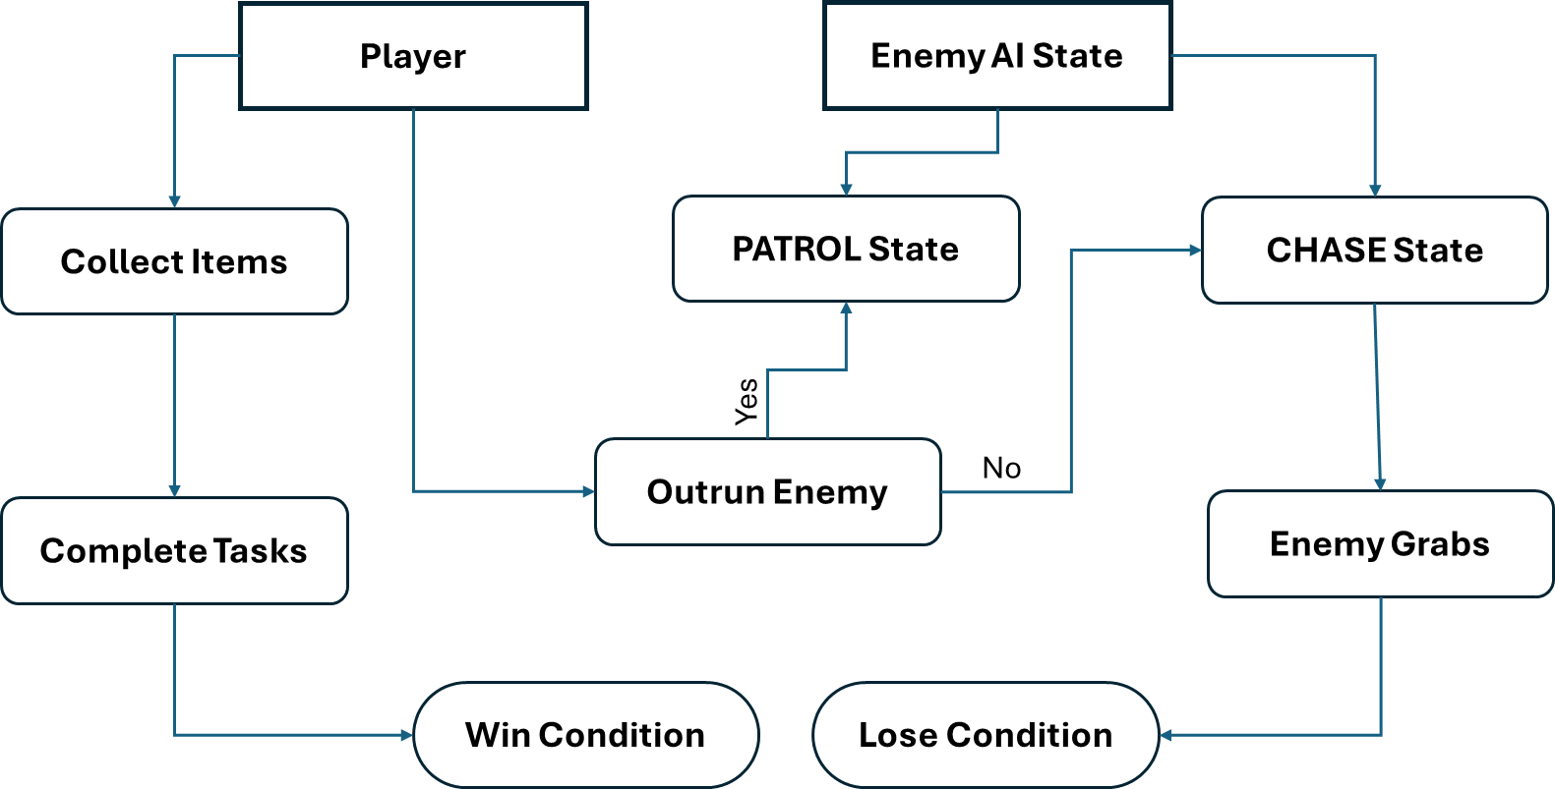

**METHODOLOGY:**

The game is a survival horror experience, challenging players to complete all quests to achieve victory.

**Object Collection:** Players collect various items essential for completing tasks and progressing.

**AI Enemies:** Dynamic AI enemies relentlessly search players, instilling a constant sense of terror.

**Google Cardboard SDK:** Integrates VR functionalities on Android devices, including stereoscopic rendering and headtracking.

**Gyroscope:** Utilizes sensor data to track players' head movements, enhancing immersion.

**Audio Management:** Implements 3D spatial audio, ambient music, and eerie sounds for a heightened atmosphere.

**User Interface (UI):** VR-friendly UI elements provide essential information and enhance player interaction.

**Win Condition:** Victory is achieved by completing all tasks and escaping from pursuing enemies.

**Lose Condition:** Failure occurs when players are caught by enemies, leading to game over.

**RESULT:**

Our project delivers a debugged experience, ensuring seamless gameplay and immersion. It explores the intricacies and rules of VR, from motion controls to spatial awareness, enhancing player engagement and interaction. The cohesive integration of features such as dynamic environments, intuitive mechanics, and immersive audiovisuals creates a harmonious and captivating experience for players, setting a new standard for VR gaming.

**CONCLUSION:**

Our VR horror game incorporates a holistic approach to gaming, seamlessly blending immersive environments with advanced technology while catering to the traditional enthusiasm for consuming horror stories. It represents a fusion of past, present, and future elements, presenting VR seamlessly into daily life experiences. Adhering to VR rules and integrating cohesive features, our game sets a new standard for immersive entertainment.